THIS ASSIGNMENT

Following a number of conversations with various ex-employees of ICA Kenya, the ICA: UK Board have now approved a research project which seeks to understand better the impact that ICA’s work has had in Kenya over the past 40 years. We see the output of the research being useful evidence for any individual and/or organisation concerned with facilitation and community development; and to support proposals/funding applications of Kenya-based organisations using the ICA approach by providing evidence that the approach is viable and effective in the Kenyan context

The intention is that this should not be a highly rigorous, sophisticated attempt to evaluate all ICA projects across Kenya, but rather a more modest, storytelling-based approach based on a few selected areas but which will nevertheless produce some interesting and valuable findings. The research will focus on five main areas in Kenya, all of which have hosted ICA programmes in the past (current thinking is for Nairobi, Isinya, IL Ngwesi, Machakos and Mariakani). The format would be conversational, eliciting stories about peoples’ experiences of what they do, how they connect with and use ICA approaches and more importantly, the difference their actions made – to themselves, the communities or in the wider society.

By taking this approach not only would data on actions and impact be gathered which could be compiled and shared more widely, but it would also begin to form a network of people who would initially be reminiscing and re-connecting, but from whom could emerge an energy to take something forward. It would also have the advantage of being significantly less costly and less dependent on outside expertise.

KABIRO HUMAN DEVELOPMENT PROJECT

Overview
The consultation using ToP methods was held in Kawangware, Kabiro Village for seven days in November, 1975. The team of consultants numbered eighty one, of who forty five were from Kawangware village itself. Approximately one hundred additional local people participated in the consult sessions on a part time basis. In addition, many were interviewed in their homes. The expertise represented by the total body of consultants encompassed a variety of fields: agriculture, animal husbandry, crop farming, community development, business management, early learning, public health, community organization, social research, marketing, masonry, veterinary science, social development, graphic art, sanitation, drainage engineering, secondary education, primary education, social engineering, public security, electrical engineering, carpentry, real estate, music composition, finance management, medicine, heavy machinery operation, family education, mechanical engineering, computer programming, radio broadcasting, health insurance, nursing, urban housing and industrial methods. Those who came from outside Kawangware were from Kenya, Australia, Hong Kong, Singapore, India, Germany, Belgium and the United States. The consultants represented both the private and public sectors and attended at their own expense. Their work was facilitated by the gracious hospitality of the officials and the people of Kawangware.

Background

Project | Project area | Interviewee | Position | Ward | Sub-county | County
KABIRO HUMAN DEVELOPMENT PROJECT | - Kabiro  - Kanunganga  - Congo  - Katina  - Muslim  - Waweru  - Kiratina | Mr. Moses Shivachi | The project treasurer, Kabiro Primary and Secondary School Manager, Director and a Teacher. | Kabiro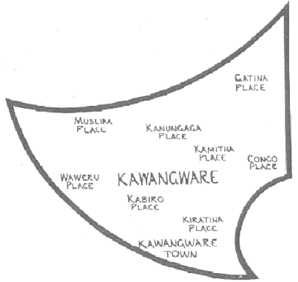 | Dagoreti North | Nairobi
KABIRO HUMAN DEVELOPMENT PROJECT |  | Luciah Wahu Mburu (mama wahu) | Kabiro Board of Trustee member. |  | Dagoreti North | Nairobi
KABIRO HUMAN DEVELOPMENT PROJECT |  | Grace akinyi | Former clinic nurse |  | Dagoreti North | Nairobi
KABIRO HUMAN DEVELOPMENT PROJECT |  | Kalithumi Omar Athuman | Community Health Village volunteer trained by ICA |  | Dagoreti North | Nairobi
KABIRO HUMAN DEVELOPMENT PROJECT |  | Anne shimuli | The current Clinic matron |  | Dagoreti North | Nairobi
KABIRO HUMAN DEVELOPMENT PROJECT |  | Benson Mwiiri Kariuki | Kabiro Youth Polytechnic graduate. |  | Dagoreti North | Nairobi
KABIRO HUMAN DEVELOPMENT PROJECT |  | Moses Atetwe Andika | Kabiro Youth Polytechnic graduate. |  | Dagoreti North | Nairobi

Initial activities in Kabiro HDP
The initial activities were Consult meetings and Strategic planning which resulted to in starting a nursery, a Primary school a Community health clinic and cleaning drainages to remove stagnant waste water and improve environmental sanitation. Women guilds were formed to make baskets which were sold internationally. Community Health Volunteer Workers were trained from the five stakes of Kabiro HDP and beyond. They trained the community members in body hygiene, home cleaning and sanitation. They trained in good nutrition, kitchen gardens and how to make dish racks. The youth started brick making, community kiosks and training apprentice in tailoring. Also the project secured land for Vegetable farming.
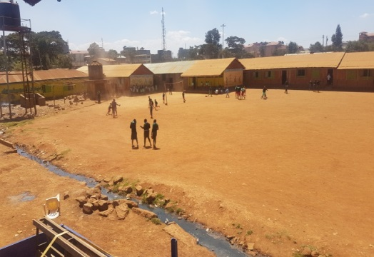

Key accomplishment/achievement
The Kabiro HDP was able to initiate and maintain 1 Nursery School – ECD, 1 Primary school, 1 Secondary school, 1 Adult Literacy and 1 clinic , training of community health workers to carryout home visits and teach nutrition sessions. The women group made baskets which were sold in Kenya and abroad. Water supply has been there since the project started managed by the women group.
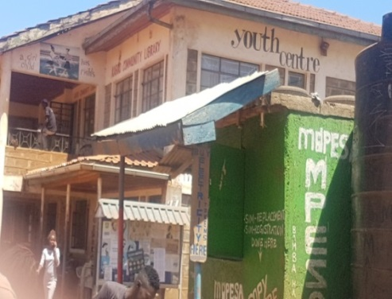

A youth polytechnic was constructed by funds raised by Ms. Elizabeth Castinglion from Switzerland, fitted with a Community library, a workshop for technical training, Car wash, Carpet wash and computer classes. In the polytechnic the youth make Akala shoes and paperbacks. Currently there are 60 youth who are involved in income generating activities within the project. They also have a football playing where they host tournaments.

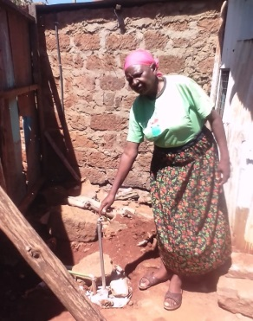
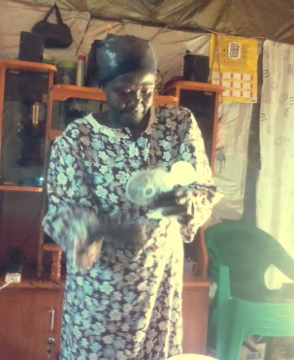
The Community Health Village volunteers were recruited, trained and some of them have continued to serve the community either still working directly from the project or individually on their own. They have continued to provide midwife services, training on health issues, planning, family planning methods and assist in raising funds for water projects. They have continued to provide nutrition training to mothers with malnourished children.
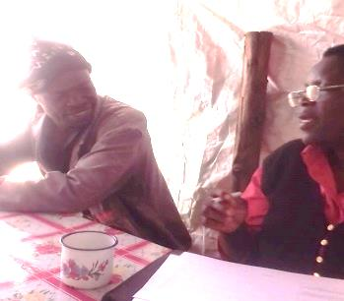

From the polytechnic, many young people have been trained in technical skills. Moses Atetwe Andika was one of the grandaunts from the polytechnic who have continued using the skills to date. This has enhanced his livelihood by enabling him to educate his children whereby the first born son has graduated and he is on his own.

Challenges and frustrations
To initiate the Kabiro Human Development Project was not a bed of roses especially for those who were ready to move on with the new approaches to community development as introduced by the Institute of Cultural Affairs (ICA). The pioneers most of whom have since died had a difficult time as Mama Wahu narrates. She might be the only one still surviving even though sickly.

There was a section of the community who didn’t like the project especially the reason being the allocation of land where the Kabiro Project seats. There some occasions when Mama Wahu, Hanah Gachoki, Mary Muthoni and Mzee Mwaura sprinkled with changaa, Also, their security was at risk because the community did not embrace what they were doing because the changaa brewing was threatened. The village was changaa brewery, so to convince the community about family planning or immunization was not easy and high level of insecurity. There was a high level of STDs and to convince them how to use condoms was very hard. There was a high level of rampant rape cases.

The other challenges were in adequate funding of the community activities. During the consult meetings and the strategic planning, good ideas were elicited from the community members but most of them lacked adequate funding. It took a long time before renovating the school facilities from wooden walls to stone through community contributions. The support from the county and national governments has become very difficult because Kabiro project is considered private institutions. Securing bursaries for pupils and students who cannot afford to pay even the little fees we charge. So far about 5% of the total students have received bursaries through vigorous looping.

Key learning about community development

The community development is a process that needs a lot of patience and open minds. One must humble herself/himself in order to associate and interact with other people. You must learn how to listen and communicate and must know how to express yourself while handling a community member. The process of community development helps and enables the members to learn how to embrace each other. The ICA methods made the community leaders to be better leaders and mobilizers. The community has realized that they can learn more when you are together. The awareness has reduced mugging due to better leadership compared to the other neighbouring communities. Social engagement of youth has reduced drug abuse in Kabiro area. If well engaged the community could be very productive. The community in Kabiro impressed the ICA training and methods and they can testify how they have benefited.

Current registration status
The Kabiro Human Development Project is still actively registered. However, the schools, Youth Polytechnic and the clinic are registered as separate entities. Even though, we were not able to see the registration certificate for the Kabiro HDP. What was hanging on the wall of Mr. Moses Shivachi’s office was the schools registration certificate.

The activities that have stopped and why
Even though Kabiro HDP is still active, it could be more vibrant if the polytechnic was still being used for the purpose it was meant to achieve. Most of the initial activities have ceased to be carried out due poor management. The equipment bought for the technical training has long been vandalized living shells of classes with broken windows. As a result, most of the training have stopped including; ttailoring, mason, canteen services and nutrition classes. The basket making by women has also stopped. The vegetable farming stopped and the land was taken over by the Lutheran Church. The clinic closed for sometimes then reopened again after hiring a new Matron. The community link these problems to the new people hired to manage the facilities. They in with selfish minds and not involving the community interest as it was before.

Evidence of changes in community
Most of the pupils and students in the schools are from within the community. The access road to Kabiro and the drainage system was constructed with ICA funding. The clinic has been approved by the government and its services appreciated by the community.
Water supply has been continuous. The Kabiro Human Development Project has become a centre for public activities which includes; Public Baraza’s, Football tournaments, Campaigns, Modelling etc. The death rates has been minimised and drug dealers were flushed out. Those who worked directly with the Kabiro project and later left have continued serving the community.

Key factors of success
The key factors of success in community development are working together. This brings accessibility to services easier and closer and makes them cheaper. The vigorous involvement of ICA at the initial stages of the project, mobilizing and involving them in identification, planning and implementation was powerful. Capacity building of community leaders, training of facilitators, training of Community Health Volunteer Workers and streamlining service providers has helped to continue even after ICA handed over the project and left.

Many children have survived as a result of the knowledge received the ICA. Those trained since early 1980’s are still training the community about breastfeeding and immunization. ICA facilitated the upgrading of kawangware market, the drainage systems and the upgrading of the main road in Kabiro. The success of children who have achieved better grades, have made them to be important people in this community. Some of the key success is the change of manual work to digital application, which makes the work lord easier. Dedication and resilience of leaders and community members support by donors and government.

The main Benefits to the Community
Essential services are closer to the community. The engagement of youth in useful activities. Women have benefited in home delivery services from the CHVWS. They have also benefited in breastfeeding and family planning activities. Drug abuse and family planning activities have been promoted among young people. Most of the communities have become self-sustainable. Some of the community members are employed as teachers and workers in other activities at the schools and the clinic. The Kabiro project is a source of education, water and health services for local people closer to it. The youth are economically empowered. The jikos made were affordable to the community. Some of the young people trained still use the skills. The pprovision of services are close to the community. Most the project initiated are self-sustaining projects.

The difference of ICA methods from those of other NGOs
ICA trainings were well planned and concentrated more on capacity building rather funding projects. Most of the people trained ICA are self-employed while other NGOs come with hand-outs on everything. The difference that ICA has brought is that they left facilities and operational programmes which were linked to public institutions for continuation. However, ICA lacked follow ups unlike other NGO’s for example Mwangaza used to assist the community until they identify other donors to continue sponsorship in education, health issues and so on. The approaches of ICA were to facilitate the community own initiative approach. The ICA was totally accountable to the work they did.

How the current government set up can benefit from ICA method
The ICA consult method could be instrumental in setting up a process that could support and attract funding to the village level for the construction of the community facilities. Upgrade the playing ground in Kabiro and support the idea of constructing storey classrooms both for the primary and secondary schools to save horizontal space. Renovate and equip social hall in Kabiro Youth Polytechnic.

The ICA grassroots approach is very effective. If the government would use the ICA approaches they can be able to develop other places especially strengthening the devolution system. The current government set up can benefit by the methods through mobilization of young people who can be able to use the dormant polytechnic. The government can also benefit through planning where the young people will actively come up with more projects. To develop a model that could incorporate integrated program that could allow the school, the clinic and youth polytechnic to operate as one integrated project. The government can use the methods to mobilize the young people and engage them in activities that will benefit them e.g. entrepreneurship and practical skills.

KAMWELENI HUMAN DEVELOPMENT PROJECT

Overview
The Kamweleni Human Development Project began in 1978 in Machakos District. It was the basic rural pilot project in Kenya. The project demonstrated what is possible when comprehensive socio-economic development takes into account all community members in the villages, including all age groups in its plan, and begins its implementation at the grass roots level.

The project was initiated through a planning consultation with a large group (around 100 people) from the village. There were five steps in the process. The first step was to get out the hopes and dreams of the villagers, or the practical operating vision. Next, the blocks or the deep underlying obstacles that keep the village from achieving its hopes and dreams, third, the practical proposals that will enable them move through the obstacles towards the vision. Fourth the consult named the events or tactical actions necessary within two years to bring off the proposals. In order to maintain comprehensive development in the two-year plan a nine programme chart was used. It is divided into three major arenas, the economic, the human and the social. In the area of the economic the objective was to have the village become self-sustaining: in social objective was self-reliance, and in the cultural it was self-confidence. Lastly, a two-year timeline of development actions was proposed and an operating model set up for the villagers to implement their actions.

Finding

Project | Project area | Interviewee | Position | Ward | Sub-county | County
KAMWELENI HUMAN DEVELOPMENT PROJECT | - Kamweleni village  - Malindi village  - chanzasu village  - Makakoi village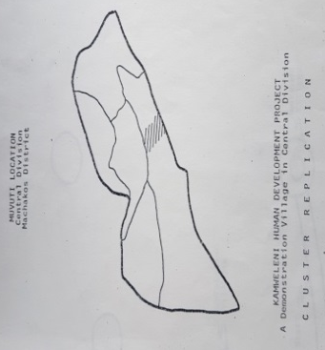 | - Zacharias muindi | Community leader | Kalama | Chanzasu | Machakos
KAMWELENI HUMAN DEVELOPMENT PROJECT |  | - Patrick mwai | Community leader | Kalama | Chanzasu | Machakos
KAMWELENI HUMAN DEVELOPMENT PROJECT |  | - John Kitonyi | Community leader | Kalama | Chanzasu | Machakos
KAMWELENI HUMAN DEVELOPMENT PROJECT |  | - Christine Boniface | A teacher at Kamweleni Primary School | Kalama | Chanzasu | Machakos
KAMWELENI HUMAN DEVELOPMENT PROJECT |  | - John Wambua | Community leader | Kalama | Chanzasu | Machakos
KAMWELENI HUMAN DEVELOPMENT PROJECT |  | - Ndunge Kiilu | Community leader | Kalama | Chanzasu | Machakos
KAMWELENI HUMAN DEVELOPMENT PROJECT |  | - Muasya Kavisi | Community leader | Kalama | Chanzasu | Machakos

Initial activities in Kamweleni HDP

The initial activities were consultation which initiated a planning process that brought about a change in ideas, attitudes and objectives of the villagers. A new sense of accomplishment, self-confidence and willingness to try new ventures was attained and an educational process was begun. The two development plan was comprehensive in nature. Phasing actuations whereby putting weight on starting with social, physical and agricultural tactical events in order for the villagers to immediately start their development plans. Other and advanced plans were developed later as the village developed. The initial community activities included: Making modern bricks, Rain water harvesting, Poultry keeping, soil conservation, The primary school was started, The HDTI was built and trainings started, The community song was formed ( kamweleni kuseo) and ICA was issued with a title deed.

At this point ICA staff moved into the village to not only work shoulder to shoulder with the villagers to bring off the tactical actions, but even more important, to impart to them development methods and motivational techniques so that they could do their own project. In addition, the staff worked with the village to create a delivery system between it and the public and private sectors.

Key accomplishment/achievement
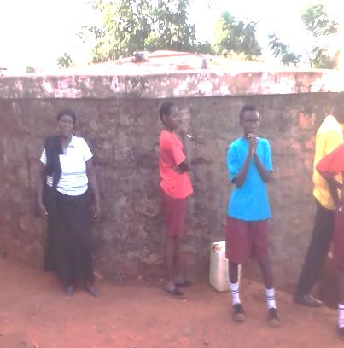
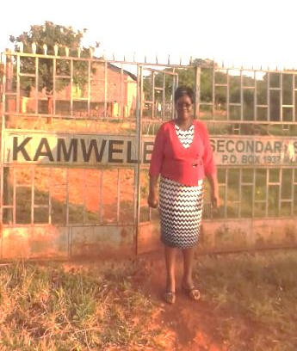
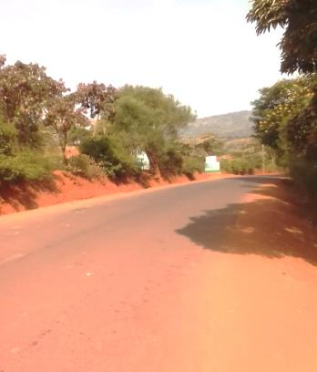
The current activities are; are the secondary school and the primary school being run by Catholic Church, and they have a sub county clinic – county government.The construction of water tank, Primary school and Secondary school. Now there is a tarmac road and rural electrification both of which were on their strategic plan. The ICA taught them to work together; through these they have learned agricultural methods that were current during those times. The community has a dam which they are constructing with support from African Sand dam Foundation. The stakes are operational with stake leaders still in place.
Figure 1 The tarmact road to Kanweleni
Figure 2 Water tank in Kamweleni
Figure 3 Head teacher at Kamweleni Secondary School

Challenges and frustrations
We have lacked proper coordination of the projects after ICA left. The water from there dam is not piped to reach the community and also there is no storage tanks to serve the community. They are worried that there is a plan to construct a sewer line from Machakos down through the village that will pollute the water and the environs. ICA didn’t have a proper handover plan to make sure the community was prepared to take over.

Key learning about community development
We can learn more skills when we are together such as modern ways of brick making. We learned that when communities are well coordinated can achieve more of their set goals and realise their dreams. They have learned about self-sustenance. They learned about modern farming (they only planted millet). They learned how to build modem houses.

Current registration status
The community can remember ICA bought land in Kamweleni but when it changed hands to become a secondary school it is unclear what happened. Whether there was a registration certificate the community doesn’t know and it was there they don’t know what happen now that the place has been sold.

The activities that have stopped and why

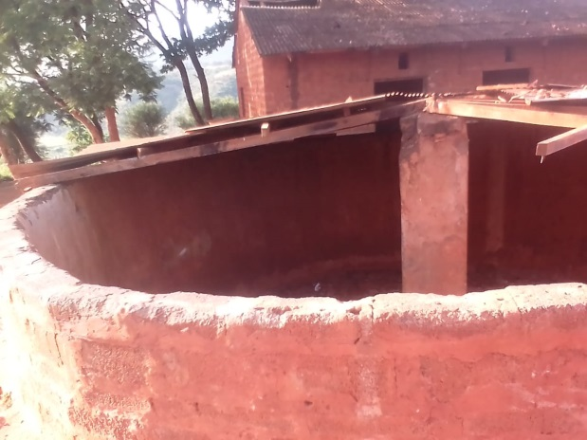
Figure 4 Water tank at Kamweleni Primary School

Most of the initial activities have stopped such as HDTI, brick making, soil conservation and the rain water harvesting is not in use and needs a major repair. The round house is still there but not in use.

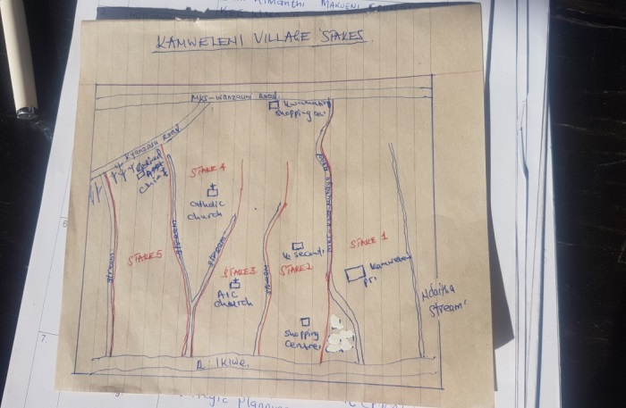

Evidence of changes in community
There is electricity; the road is tarmac, a secondary school and a dam for storing water. Stake meeting still held long after ICA left.

Key factors of success

One key factor for success was following their time line and making changes where they stagnated in the process of achieving their goals. The ICA came and facilitated the community togetherness. The stakes working together to plan for their activities at the smallest level of the village generates comprehensive ideas

The main Benefits to the Community

The village now have very good mode of transport which saves time and it is also cheap to travel. The community have benefited with the secondary school which has improved into a boarding school. The main benefit of this project is that, their children go to school where by they don’t track long distance. Easy communication, between teachers and parents.

The difference of ICA methods from those of other NGOs

We learned how to work together as a community and as groups simultaneously which was different from other NGOs. ICA approach was including every community member in the planning of the development projects. The community are responsible for their own development.

How the current government set up can benefit from ICA method

The ICA people brought development that is manifested e.g. stakes are working. They have formed various groups eg welfare groups that manages funerals and other activities. We became more responsible for our won projects, we used doop (do your own projects).
The youth became more responsible and minimized drunkardness and enhances security.

How the current government set up can benefit from ICA method

The participatory down up approach could strengthen the County public participation emphasis on community development. Other NGOs has no procedure, even to mobilize community. Since ICA left there is no organisation that has ever come to bring development to kamweleni

Vwevwesi Human Development Project

Introduction
The Vwevwesi Human Development Project (HDP) was initiated in October 1980. Then later expanded to cover the 4 villages within Kizingo sub-location by March 1981, to Mwarakaya sub-location covering 5 villages by October 1981 and to the 4 villages in Pingilikani sub-location by November 1981. These then became Mwarakaya Location Cluster Project covering 3 sub-locations, 13 villages with a population of 15, 467.
The replication of cluster projects continued in the Region covering Chonyi, Kaloleni, Jibana, Kambe/Ribe, Ruruma and Rabai Location Cluster Projects with grand total 120 villages, 25 sub-locations, and 7 locations with a total population 108,256 people by 1988.

Finding
Project | Project area | Interviewee | Position | Ward | Sub-county | County
VWEVWESI HUMAN DEVELOPMENT PROJECT | - Chituoni  - Mwambani  - Mkalakalani  - Mdomo  - Ryakalui  - Mtunguni | - Ngana William | chairman | Samburu kyengoni, | Kinango | Kwale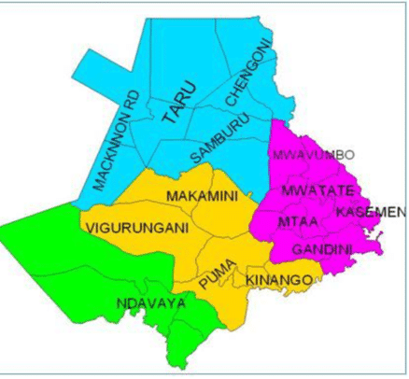
VWEVWESI HUMAN DEVELOPMENT PROJECT |  | - Luo nyamawi |  | Samburu kyengoni, | Kinango
VWEVWESI HUMAN DEVELOPMENT PROJECT |  | - Mulongo bora |  | Samburu kyengoni, | Kinango
VWEVWESI HUMAN DEVELOPMENT PROJECT |  | - Chiphenyo mzigo |  | Samburu kyengoni, | Kinango
VWEVWESI HUMAN DEVELOPMENT PROJECT |  | - Masika kadungo |  | Samburu kyengoni, | Kinango
VWEVWESI HUMAN DEVELOPMENT PROJECT |  | - Kanga mzigo |  | Samburu kyengoni, | Kinango
VWEVWESI HUMAN DEVELOPMENT PROJECT |  | - Mboaze nyiro |  | Samburu kyengoni, | Kinango
VWEVWESI HUMAN DEVELOPMENT PROJECT |  | - Nanzigu mwanza |  | Samburu kyengoni, | Kinango
VWEVWESI HUMAN DEVELOPMENT PROJECT |  | - Mupa besa |  | Samburu kyengoni, | Kinango
VWEVWESI HUMAN DEVELOPMENT PROJECT |  | - Nyiro mandara |  | Samburu kyengoni, | Kinango
VWEVWESI HUMAN DEVELOPMENT PROJECT |  | - Priscah mwachondo |  | Samburu kyengoni, | Kinango

Initial activities in Vwevwesi HDP

The initial activities were Chituoni mobile clinic, Soap making (mwarubaini), Printing growth monitoring cards (children under 5 years), Supplementary feeding for undernourished children, Started a nursery school (3-7 years old ) grown to primary school
Goat rearing and Training for modern farming (maize, millet etc.

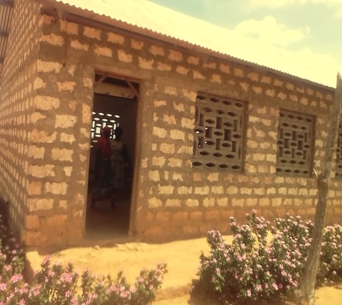
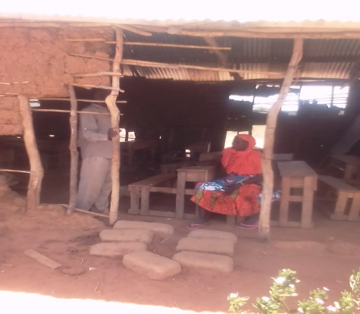
Key accomplishment/achievement
Accessibility to health services, facilities for nursery to primary up to class 7, training on modern farming, they have increased food security and no children who are undernourished due to nutrition training provided by ICA. The trained CHWs (Community Health Workers) are still active. The children are educated by the income from goat rearing which was initiated by ICA.

Figure 5 New School
Figure 6 Old School

Challenges and frustrations
The drought has been repeatedly and severely affected the area where livestock is most hit. No food in shamba due to insects menace. The absenteeism of mothers when they were needed in the clinic for child weighing, training and feeding programmes. Acceptance of family planning method was a challenge because men were not allowing their wives to go to the clinic. Pregnant women delivered in vehicles and also checkups.

Key learning about community development

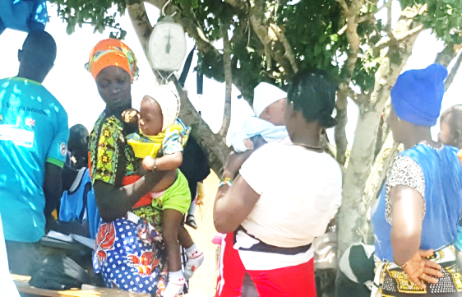
The child care and growth monitoring is important and more on children under 5 years. Togetherness attracts services from public institutions and non-governmental within the region. Some of the benefits of togetherness in the region training in modern farming, nutrition, soap making (mwarubaini, aloe Vera, coconut oil, caustic soda, bulk working and planning together.

Current registration status
The project is registered through social services and it has expired but the community is in the process of renewing.

The activities that have stopped and why
The growth monitoring and immunization, modern farming, goat rearing and water purification. Printing of clinic cards that was taken over by a private company. Cattle and goat rearing because of drought.

Evidence of changes in community
The primary school is still operational (taken by the government)

Key factors of success
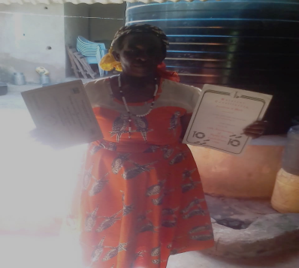

The community has learned that listening skills as a leader, harmonizes their group discussions, leadership qualities and because of these services has come closer to the community for example health services. The children are no longer undernourished and are getting education in primary school closer to them. The mothers have known proper ways of how to feed children.

Figure 7 Training Certificates

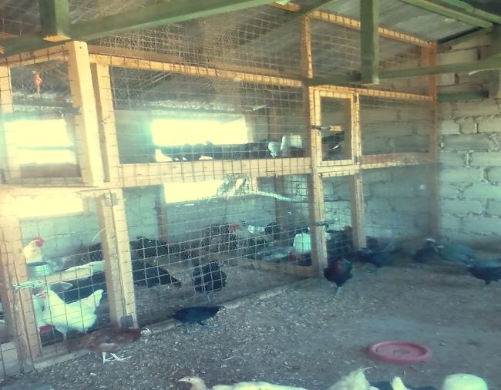

The main Benefits to the Community
The construction of Primary school, upgrade of the clinic into a health center, individually we have brought changes through the training received and income from the clinic (paid by county). The community learnt about leadership skills and modern farming methods from ICA and still uses these methods especially in modern farming. The income generating projects are still active (small businesses).

Figure 8 Income generating Activity

The difference of ICA methods from those of other NGOs

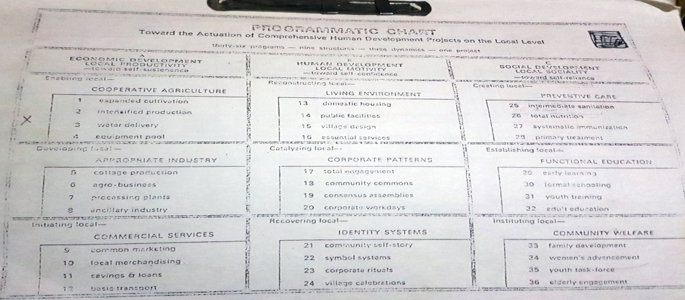

ICA involved and engaged the whole community while other NGOs involved just few families. Their activities such toilet construction didn’t work well because while they continued constructing the toilets the community continued going to the push in their targeted communities.

How the current government set up can benefit from ICA method
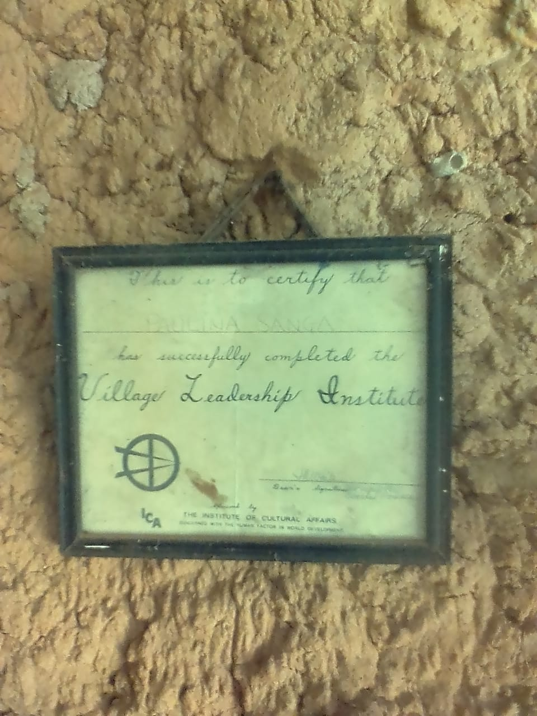
The government can use Community Health Workers that were trained by ICA and give them more training. The government can use ICA methods in resource sharing and initiating from the village level.

Isinya Cluster Project

Introduction
Isinya location is located in Isinya Ward of Kajiado County and it is characterized by fertile soils but with unpredictable rain patterns especially the long rains which could be 500mm in ecozones LM5 (Lowland zone).
Project | Project area | Interviewee | Position | Ward | Sub-county | County
ISINYA  CLUSTER  PROJECT | - Ilpolosat village  - Lenchani village  - Olmeirrui village  - Osewan village  - Lema village  - Naserian village  - emampriswai village  - Olepolos village  - Okmoti village  - Embolioi village  - Enkirikirri village | Mr. Mbashe | Chief | Isinya | Isinya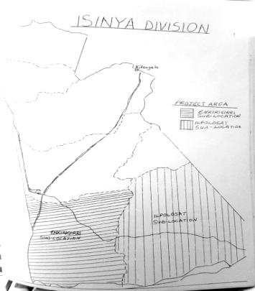 | Kajiado
ISINYA  CLUSTER  PROJECT |  | Sekenoi | Sinior assistant Chief | Isinya |  | Kajiado

Initial activities in Isinya Cluster

Key accomplishment/achievement

Challenges and frustrations

Key learning about community development

Current registration status

The activities that have stopped and why

Evidence of changes in community

Key factors of success

The main Benefits to the Community

The difference of ICA methods from those of other NGOs

How the current government set up can benefit from ICA method

